**Distribution of rainfall in the world versus Earth's coating movement.**

Autor: Bogdan Góralski

bogdangoralski@wp.pl

Base on my previous work titled **Climate changes versus Earth's geoide shape changes**

I can make the statement:

" In my previous work I presented the concept of rotational motion of the Earth controlled by the movements of the masses of the Solar System. Changes in gravity and magnetism (?) in the Solar System cause the Earth's coating movement against the ecliptic. Earth's coating consisting of earth's crust and mantle rotates by slipping on the surface of the outer, liquid and metallic earth nucleus. Below I present evidence that the movement of the earth's coating is the cause of the constellation's star movement, and the precession of the earth's axis is absent. This observer on Earth is changing position, and star constellations are probably not moving.

Earth coating movement and climate change

Earth coating movements cause climate change, changes in the velocity of Earth's geoid circulation, and earthquakes. These phenomena are correlated, proving numerous scientific papers, including those cited below".

If we want to predict the course of Indian Monsoon we should take into account LOD ( length of Earth's day ) changes. We observed by the comparison two graphs:

1. the course of LOD changes in period 1870-2010 year.

Source: https://hpiers.obspm.fr/eop-pc/index.php

2. the course of Indian Monsoon in period 1870-2010 year.

Source: https://www.rmets.org/sites/default/files/abstracts/Mar/16032013-slingo.pdf

The result is on the Fig.1 and we see:

-drought in the Indian Monsoon usually connected with bigger length of earth's day,

-floods are more often connected during lowering length of earth's day

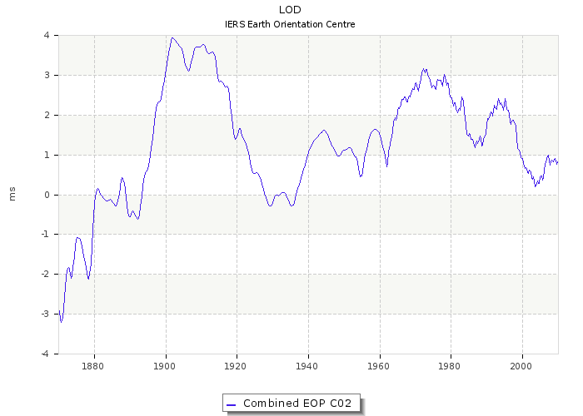

1. the course of LOD changes in period 1870-2010 year.

Source: https://hpiers.obspm.fr/eop-pc/index.php

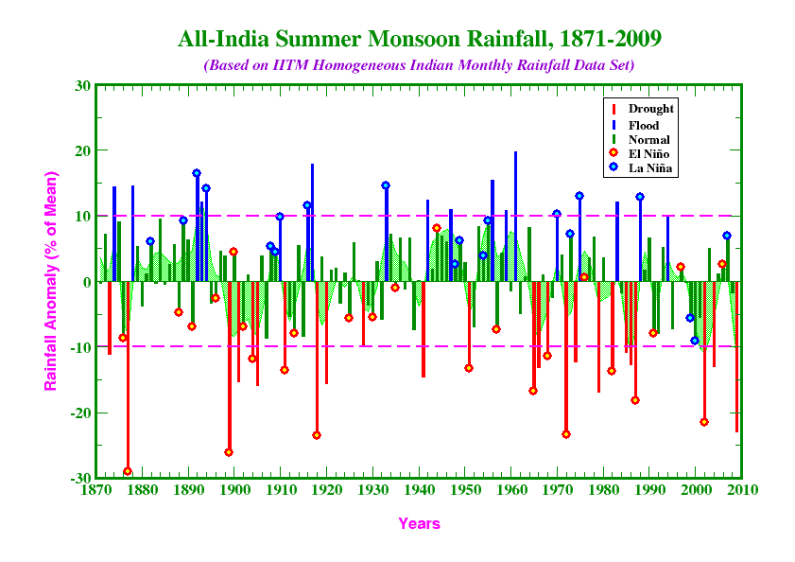

2. the course of Indian Monsoon in period 1870-2010 year.

Source: https://www.rmets.org/sites/default/files/abstracts/Mar/16032013-slingo.pdf

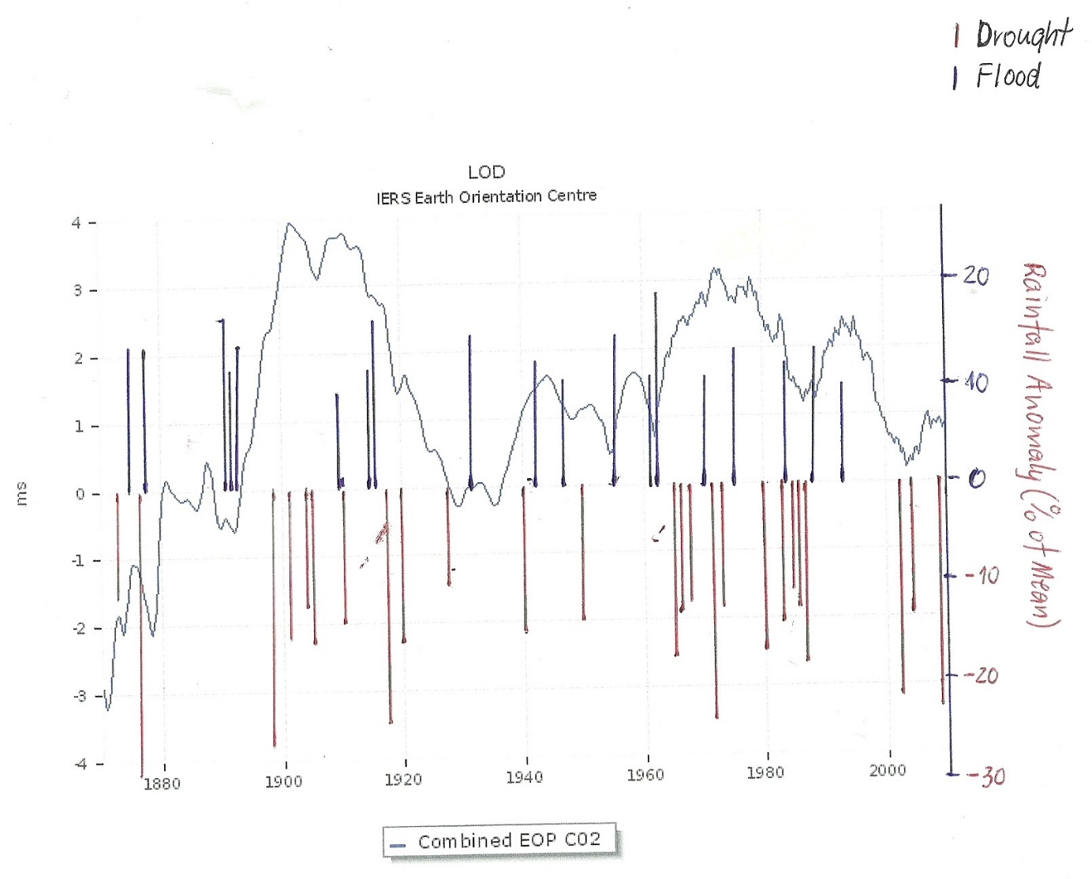

Fig.1 The course of Indian Monsoon versus LOD changes (length of Earth’s day) during period

of years 1870-2010.

Graf made by Bogdan Góralski

-drought during Indian Monsoon - red color below the zero line on the right scale,

-floods during Indian Monsoon – blue color above the zero line on the right scale.

Left scale LOD changes (grey blue continuous line) in [milliseconds]

If we made sure that my observations are the rule, we could have predicted the general course of Indian Monsoon in the future because today we can predict the course od LOD changes for 180 days ahead. And what will be if we focusing our research on the causes of LOD changes....

Warszawa, 19th March 2017

Fig.2 Annual rainfall in all India during period 1901-2015 of monsoon JUNE-SEPTEMBER (in mm-blue color) versus LOD -excess of the duration of the day ( in miliseconds) to 86400 second (red color)

Graf made by Bogdan Góralski

Source of data: Indian Monsoon link: https://data.gov.in/catalog/rainfall-india

LOD link: https://www.iers.org/IERS/EN/Science/EarthRotation/LODsince1623.html;jsessionid=720AA8FEA9C00E696AEAE984F3F0BF91.live2?nn=12932

The result is on the Fig.2 and we see:

-more dry weather in the Indian Monsoon usually connected with bigger length of earth's day,

-more rain is connected with lowering length of earth's day in the Indian Monsoon

Fig.3 Annual anomaly of rainfall in all USA during period 1901-2015 (in inches-red color) versus LOD -excess of the duration of the day ( in miliseconds) to 86400 second (blue color)

Graf made by Bogdan Góralski

Source of data: Annual anomaly of rainfall in all USA during period 1901-2015 link: https://www.epa.gov/sites/production/files/2016-08/precipitation_fig-1.csv

LOD link: https://www.iers.org/IERS/EN/Science/EarthRotation/LODsince1623.html;jsessionid=720AA8FEA9C00E696AEAE984F3F0BF91.live2?nn=12932

The result is on the Fig.3 and we see:

-more dry weather in the USA usually connected with lowering (smaller) length of earth's day,

-more rain in all USA is connected with bigger length of earth's day

Fig.4 Annual anomaly of rainfall in all USA during period 1901-2015 (in inches-blue colour) versus 2 annual rainfall in all India during period 1901-2015 of monsoon JUNE-SEPTEMBER (in mm-red colour)

Graf made by Bogdan Góralski

Source of data: Indian Monsoon link: https://data.gov.in/catalog/rainfall-india

Source of data: Annual Annual anomaly of rainfall in all USA during period 1901-2015 link: https://www.epa.gov/sites/production/files/2016-08/precipitation_fig-1.csv

The result on the Fig.4 and we see:

-more dry weather in the Indian Monsoon usually connected with more rain in USA and vice versa the more wetter weather in the Indian Monsoon the more dry weather in USA.

Explanation of these processes you can find in my articels and book on the Researchgate portal.

Jakuszowice, 2nd August 2017, 2:15 Bogdan Góralski

Fig.5 Annual anomaly of rainfall in all USA during period 1901-2015 (in inches-red colour) versus 2 annual rainfall in all Congo (equatorial Africa) during period 1901-2015 of JUNE-SEPTEMBER (in mm-blue colour)

Graf made by Bogdan Góralski

Source of data: Rainfall in Congo -Link: CLIMATE CHANGE KNOWLEDGE PORTAL

http://sdwebx.worldbank.org/climateportal/index.cfm?page=downscaled_data_download&menu=historical

Source of data: Annual anomaly of rainfall in all USA during period 1901-2015 link: https://www.epa.gov/sites/production/files/2016-08/precipitation_fig-1.csv

As on the Fig.4 we see on the Fig.5 a negative correlation of two variables rainfall in Congo(equatoria Africa) and USA. We will see a positive correlation between two variables on the Fig.6: rainfall in Congo and monsoon rainfall in all India.

Fig.6 Annual rainfall JUNE-SEPTEMBER in Congo (equatorial Africa) during period 1901-2015 (in mm-red colour) versus 2 annual rainfall in all India during period 1901-2015 of monsoon JUNE-SEPTEMBER (in mm-blue colour)

Graf made by Bogdan Góralski

Source of data: Indian Monsoon link: https://data.gov.in/catalog/rainfall-india

Source of data: Annual rainfall in Congo -link: CLIMATE CHANGE KNOWLEDGE PORTAL

http://sdwebx.worldbank.org/climateportal/index.cfm?page=downscaled_data_download&menu=historical

How is possible to explain above correlations???

The "rising" and "sinking" zones move northward and southward with the Sun's path. Thus, the wet area near the Equator moves northward into the Northern Hemisphere in its summer, and southward into the Southern Hemisphere during its summer. Similarly, the dry zones and wet zone at higher latitudes shift northward and southward throughout the year.

The result of these shifting zones are latitude bands with distinctive precipitation characteristics:

0–5° latitude: wet throught the year (rising zone)

5–20° latitude: wet summer (rising zone), dry winter (sinking zone)

20–30° latitude: dry all year (sinking zone)

30–50° latitude: wet winter (rising zone), dry summer (sinking zone)

50–60° latitude: wet all year (rising zone)

60–70° latitude: wet summer (rising zone), dry winter (sinking zone)

70–90° latitude: dry all year (sinking zone)



Fig. 4. Rainfall over Iran [42.5_ Ee65.5_ E; 25_ Ne41_ N ] for 6 ka BP to present (blue line) and the solar insolation [W/m2] at 31_ N (red line) from ECHO-G simulation during (a)

Summer (JJA) and (b) Winter (DJF). Time-series are smoothed using 201 years running mean. (For interpretation of the references to colour in this figure legend, the reader is

referred to the web version of this article.)

In my latest works for example HOW TO PREDICT THE RAINFALL IN INDIA AND USA?, I told about phenomenon which are in my opinion, evidence of movements Earth's coating, ie. the crust and the mantle around the Earth's liquid core. The inversion of precipitation in the USA (50-30 degrees latitude) and India (30-10 degrees latitude) and Congo (5,-10 degrees of lattitude)tends to suggest that the precipitation zones seem to migrate. In my opinion rainfall zones have a fixed position relative to the ecliptic, but the movements of the Earth's coating make India moves in or out of the zone of summer rainfall, like the USA moves in and out of the wet zone of winter precipitation middle latitudes (50-30 degrees of latitude), which causes a cyclical variation of precipitation depends on the movements of the earth's coating. Abundant obfite Rainfall in Congo correlated positively with all India monsoon rainfall ponieważ ruch powłoki ziemskiej jednocześnie przemieszcza obszar Konga in rising zone (ITCZ 5,-5 degrees of latitude) which is wet all year long, a obszar Indii w strefę wet summer (20-5 of latitude). Reversal movement to the south pole of the coating of the Earth result in decrease rainfall in Congo, India and increase rainfall in USA.

If the North Magnetic Pole approaches to Siberia, the coating of the Earth will move so that Siberia will be close to the axis of rotation of the Earth. Will be cooler and wetter in the northern part of the Eurasian continent, warmer in the northern zone of North America. Will be dryer in the south of the USA. Climate zones will shift accordingly about 15 degrees of latitude as to change the spread zones of lush vegetation. Will be Increase in the number of earthquakes in the Mediterranean region, the region of Central America, the Malay Archipelago, and Australia.North Eurasian continent is the main wheat growing region. The cooling of this region of the globe and displacement of zones of precipitation will reduce crop production and will cause famine

References:

Global Distribution of Precipitation- link:

<http://www.waterencyclopedia.com/Po-Re/Precipitation-Global-Distribution-of.html#ixzz4Bj24W4Vx>

2500 Years of European Climate

Variability and Human Susceptibility

Ulf Büntgen,1,2* Willy Tegel,3 Kurt Nicolussi,4 Michael McCormick,5 David Frank,1,2

Valerie Trouet,1,6 Jed O. Kaplan,7 Franz Herzig,8 Karl-Uwe Heussner,9 Heinz Wanner,2

Jürg Luterbacher,10 Jan Esper11

https://www.uibk.ac.at/geographie/forschung/dendro/publikationen---pdf-files/2011-buentgen-et-al-science---somb.pdf

Towards modeling the regional rainfall changes over Iran due to the

climate forcing of the past 6000 years

Bijan Fallah*, Sahar Sodoudi, Emmanuele Russo, Ingo Kirchner, Ulrich Cubasch

Institute of Meteorology, Free University of Berlin, Carl-Heinrich-Becker-Weg 6-10, 12165 Berlin, Germany

https://www.researchgate.net/publication/283257953_Towards_modeling_the_regional_rainfall_changes_over_Iran_due_to_the_climate_forcing_of_the_past_6000_years

**A seesaw in Mediterranean precipitation during the Roman Period**

**linked to millennial-scale changes in the North Atlantic**

**B. J. Dermody**1**, H. J. de Boer**1**, M. F. P. Bierkens**2**, S. L.Weber**3**, M. J. Wassen**1**, and S. C. Dekker**1

https://www.academia.edu/4006659/A_seesaw_in_Mediterranean_precipitation_during_the_Roman_Period_linked_to_millennial-scale_changes_in_the_North_Atlantic