History of grain prices versus Earth's coating shift

Bogdan Góralski

Library of Historical Instytut of University of Warsaw

Base on my previous work titled Climate changes versus Earth's geoide shape changes
I can make the statement:
" In my previous work I presented the concept of rotational motion of the Earth controlled by the movements of the masses of the Solar System. Changes in gravity and magnetism (?) in the Solar System cause the Earth's coating movement against the ecliptic. Earth's coating consisting of earth's crust and mantle rotates by slipping on the surface of the outer, liquid and metallic earth nucleus. Below I present evidence that the movement of the earth's coating is the cause of the constellation's star movement, and the precession of the earth's axis is absent. This observer on Earth is changing position, and star constellations are probably not moving.
Earth coating movement and climate change
Earth coating movements cause climate change and increasing of grain prices, changes in the velocity of Earth's geoid circulation, and earthquakes. These phenomena are correlated, proving numerous scientific papers, including those cited below".

Fig. 1. Grain prices in China and Europe in 1738-1906 (in grams of silver per kilogram)
Sources: Rice prices in the lower reaches of Yangzi and wheat prices in Zhili-in North China from the work of Lillian M.Li, Integration and Disintegration in North China's Grain Markets, 1738-1911, The Journal of Economic History, Vol.60, No.3 (Sept.2000), European prices from Robert C. Allen's work The Great Divergence in European Wages and Prices from the Middle Ages to the First World War, Explorations in Economic History, 38, 2001, 411-447

The above chart comes from the following work resulting from the cooperation of many authors:
Wages, Prices, and Living Standards in China, Japan, and Europe, 1738-1925.

Robert C. Allen, University of Oxford, Nuffield College,
bob.allen@nuffield.oxford.ac.u
Nuffield College, New Road, Oxford OX1 1NF
Jean-Pascal Bassino, Maison Franco-Japonaise, Tokyo / Hitotsubashi University,
Tokyo, bassino@mfj.gr.jp
Debin Ma, GRIPS / FASID Tokyo, debinma@grips.ac.jp
Christine Moll-Murata, Utrecht University, Christine.Mollmurata@let.uu.nl
Jan Luiten van Zanden, Utrecht University / International Institute for Social History,
Amsterdam, jvz@iisg.nl
Link to the above work: http://www.iisg.nl/research/jvz-wages_prices.pdf

Rainfall is dependent on insolation and atmospheric circulation because they are associated with currents rising in the atmosphere that are raiseing high-humidity air that condenses to create clouds that bring rain. When the Earth's coating moves in relation to the ecliptic plane, ie the Sun, zones with life-giving rainfall move on the Earth's surface and there are fertile zones in agriculture i.e.well-hydrated zones and crop failure in dry areas. This results in an increase or decrease in food prices in different regions of the globe at the same time as shown in Figure 1. The shift of the earth's coating against the ecliptic in 1790-1810 caused drought in Western Europe, a drastic rise in food prices and, in effect, a bloody French Revolution. At that time in Asia there were better climatic conditions than in Europe and food prices were stable. Since 1890, there has been a global increase in food prices (there was already a global food market, which was transported by steamers), which was probably related to the lack of precipitation in the countries of southern Europe and southern Asia. This shows the next movement of the earth's coating, which shifted the precipitation of the life-giving monsoon from the north more towards the south of Asia.

Rys.2 Figure 7. Change in the length of day since 1620 (after Stephenson F. R., Morrison L. V., Philos. Trans. R. Soc. London, 1984, A313, 47-70).
Stephenson F. R., Morrison L. V., Philos. Trans. R. Soc.London, 1995, A351, 165- 202.
http://www.cl.cam.ac.uk/~mgk25/time/metrologia-leapsecond.pdf. Pobrane 2012 r.

Source of data of earthquakes: Author’s own analysis based on data from the U.S.G.S. Earthquake Hazard Program. Source of data: http://neic.usgs.gov/neis/eqlists/7up.html

With the increase in the LOD value, drought in India grows and rain falls in the USA and vice versa what we can see in the figure below. Changes in LOD values are related to the gravitational interaction of the Moon, Sun and planets.

Fig.3. Annual anomaly of rainfall in all USA during period 1901-2015 (in inches-blue colour) versus 2 annual rainfall in all India during period 1901-2015 of monsoon JUNE-SEPTEMBER (in mm-red colour)
Graf made by Bogdan Góralski
Source of data: Indian Monsoon link: https://data.gov.in/catalog/rainfall-india
Source of data: Annual Annual anomaly of rainfall in all USA during period 1901-2015 link: https://www.epa.gov/sites/production/files/2016-08/precipitation_fig-1.csv
The result on the Fig.4 and we see:
-more dry weather in the Indian Monsoon usually connected with more rain in USA and vice versa the more wetter weather in the Indian Monsoon the more dry weather in USA.
Explanation of these processes you can find in my articels and book on the Researchgate portal.

FIG. 4. Smoothed 2-year running variance v, of yearly rainfall totals (mm) derived from observations of 14 German stations by Baur, for the period 1851-1983. Arrows mark epochs of minima in the 9-year running variance v of the sun's orbital angular momentum. Open circles designate respective maxima in v. The significant correlation between these solar and terrestrial data is corroborated by rainfall observations from England, Wales, eastern U.S., and India.

Source of Figure 6.: Landscheid T.,1990, Relationship Between Rainfall in the Northern Hemisphere and Impulses of the Torque in the Sun's Motion,

http://bourabai.narod.ru/landscheidt/relationship.htm

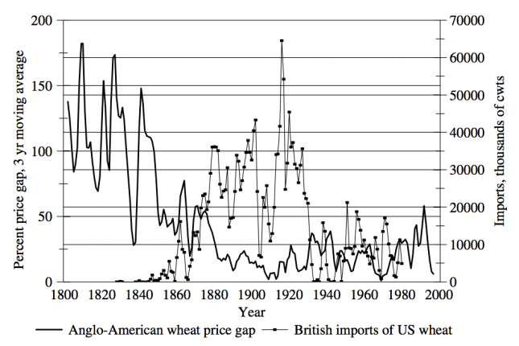

Fig.5. Anglo-American wheat Trade, volume and price, 1800-2000 – O’Rourke & Williamson (2015) note 15

Source of image:

https://ourworldindata.org/food-prices/#note-15

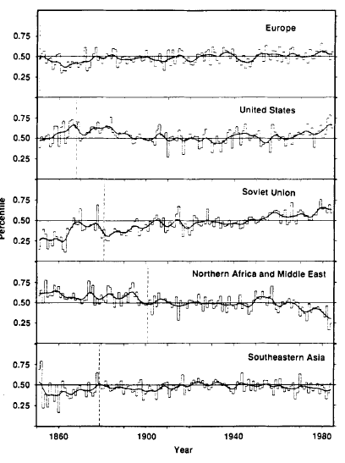
Fig. 6. Rainfall indicators for Europe, the USA, Russia, North Africa, the Middle East and Southeast Asia in the years 1850-1980

The above drawing come from the following work done by renowned climatologists based on reliable research material:
Precipitation fluctuations over the Northern Hemisphere land area Since Mid-19th Century
R.S.Bradley, H.F.Diaz, J.K. Eischeid, P. D. Jones, P.M.Kelly, C.M. goodes
http://www.geo.umass.edu/faculty/bradley/bradley1987c.pdf
Science, vol.237 p. 171-175 July 10, 1987.

Regional drought shifts (1710–2010) in East Central Asia and linkages with atmospheric circulation recorded in tree-ring δ18O
Article Regional drought shifts (1710–2010) in East Central Asia and...
Drought occurrence and duration in central Asia are of important socioeconomic, ecological, and geophysical significance and have received increasing research attention in recent years. Understanding long-term drought trends and their driving forces require reliable records of past drought variability with broad spatial representativeness. Here, we compiled four tree-ring δ¹⁸O records from eastern central Asia (ECA) and composited them into a drought-sensitive proxy to explore regional ECA moisture variations over the past 301 years (1710–2010 CE). A robust regional standardized precipitation-evapotranspiration index (SPEI) reconstruction was established based on the tree-ring cellulose δ¹⁸O fractionation mechanism and statistically significant proxy-climate relationships. We identified prominent droughts in 1710–1770, 1810–1830, and the beginning of the twenty-first century, and a regime shift to a persistently wet period from the 1880s to 2000. Our reconstruction reveals the impact of drought and pluvial patterns on the decline of Zhungar Empire, and on historical agricultural and socio-economical activities, including increased migration into ECA during the 1770–1800 pluvial. Our findings also suggest that wet conditions in the twentieth century in ECA were related to a strengthening of the westerly circulation and thus shed light on large-scale atmospheric circulation dynamics in central Asia.

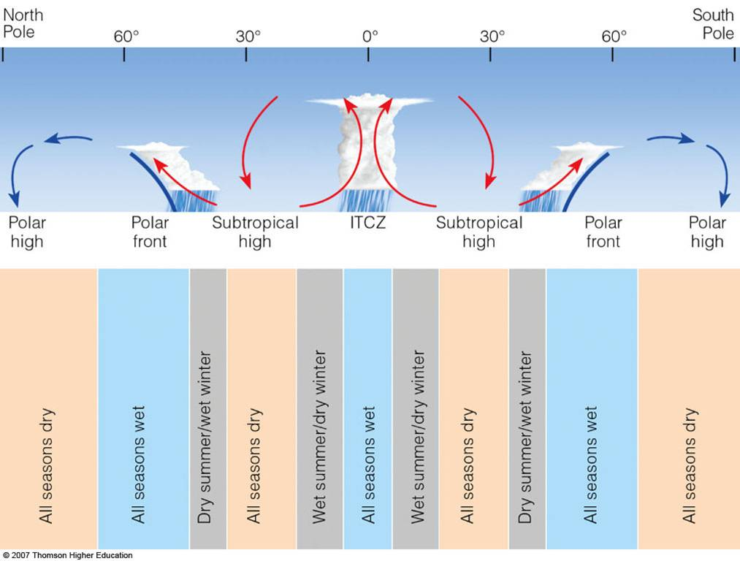

http://apollo.lsc.vsc.edu/classes/met130/notes/chapter17/glob_prec_w.html

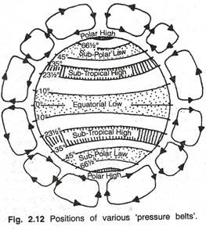 http://www.geographynotes.com/atmosphere/atmospheric-pressure-measurement-distribution-and-controlling-factors/854

Atmospheric Pressure: Measurement, Distribution and Controlling Factors
Article shared by : P. Tiwari

Source of image:
http://www.climate4you.com/GlobalTemperatures.htm#Earths rotation and global temperature

