Living conditions in Russia and climate changes in period 1700-1900 years.
Author Bogdan Góralski

In Russia, systematic research on the growth and health of candidates for the army was conducted.
Because, as shown earlier in numerous works, the change the height of the members of the human population depends on nutrition, and the diet improves and deteriorates cyclically to the rhythm of climate change. Favorable climatic conditions result in better nutrition of the population and a greater height of its members and vice versa.
In the chart below, we see that the candidates for the Russian army-conscripts, in the period 1700--1790 had deteriorating board, nutrition which was signaled by a declining height in conscripts.
In the period 1790-1915, the conditions of feeding Russian conscripts improved, which is indicated by the height, increasing among the candidates for the Russian army.
This shows that the climate conditions in Russia deteriorated in the period 1700-1790, and were fluctuating periodically, improving in general until 1915. Demographic data on the Russian population indicate that in the period 1790-1915, the number of population of Russia grew rapidly, and anthropological research indicates that the abundance of food affects the masculinization of the population - an increase in the number of men in the population. The society with the majority of men is more aggressive, which explains the revolutionary behavior of the Russian population when the climate crisis of the early 20th century came.
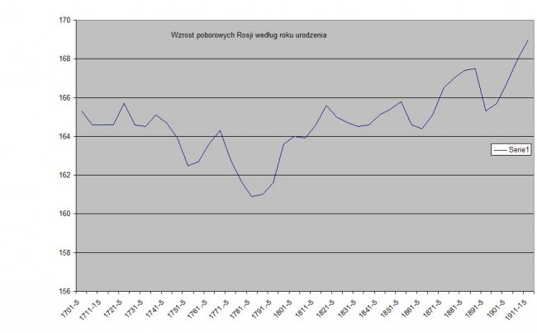
Fig. 1 Changes of the height of candidates for the Russian army in the period 1700-1915.
The chart was prepared by Bogdan Góralski based on the data from tables 4.1.5.1 and 8.5 contained in the book by Boris Mironov (2014), The standard of living and Revolutions in Russia, 1700-1917, Routledge, London-New York.

Warsaw, January 15-16, 2016, 7:00 PM, 35 Bogdan Góralski

